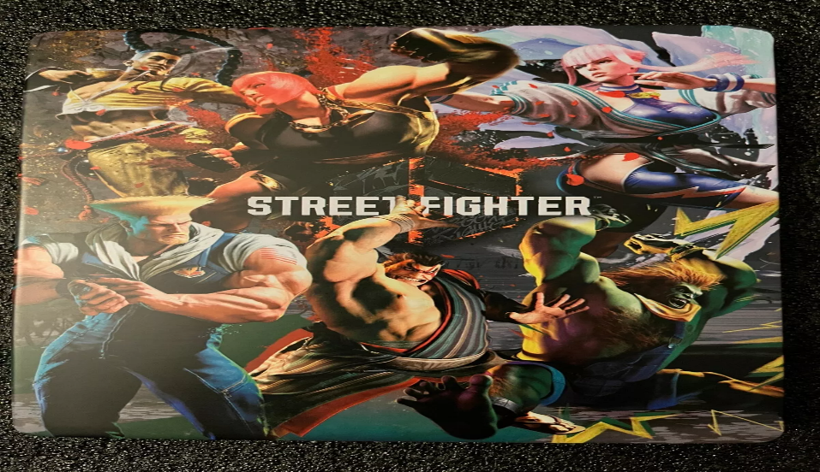

*Street Fighter 6:*

1️. **Three Core Game Modes**

* **World Tour:** Open-world RPG-style story mode with a custom character.
* **Fighting Ground:** Classic **versus, training, and arcade modes**.
* **Battle Hub:** Online social space for multiplayer battles and tournaments.

2️. **New & Returning Characters**

* Features a **mix of classic fighters (Ryu, Ken, Chun-Li, Cammy, Guile, etc.)** and new characters like **Luke, Jamie, Marisa, JP, and Manon**.

3️.**Revamped Combat System**

* **Drive System:** Allows parries, rush attacks, enhanced moves, and counters.
* **Three Control Styles:** Classic (traditional), Modern (simplified inputs), and Dynamic (AI-assisted).

4️. **Enhanced Graphics & Immersion**

* Powered by **RE Engine**, bringing **detailed character models, fluid animations.**
* **Real-Time Commentary Feature** for an esports-style experience.

5️.**Cross-Platform Play & Strong Netcode**

* **Cross-play support** across PlayStation, Xbox, and PC.
* **Rollback netcode** ensures smooth and lag-free online matches.